***FitLife Requirement Analysis Diagrams***

### ***1. Use Case Diagram***

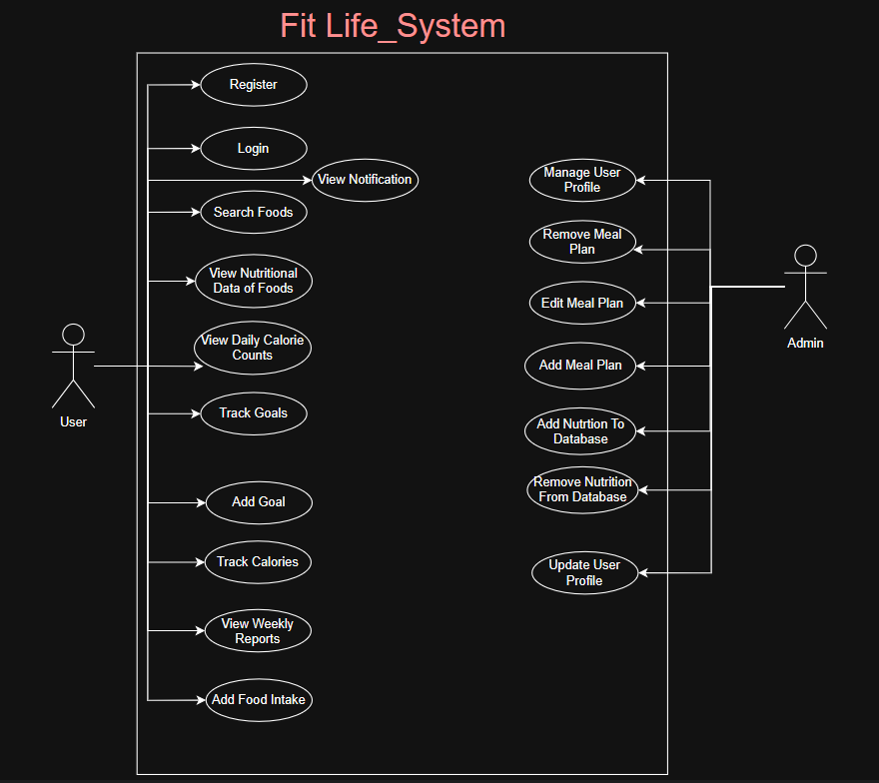

### 

### 

### 

### 

### 

### 

### 

### ***2. Data Model***

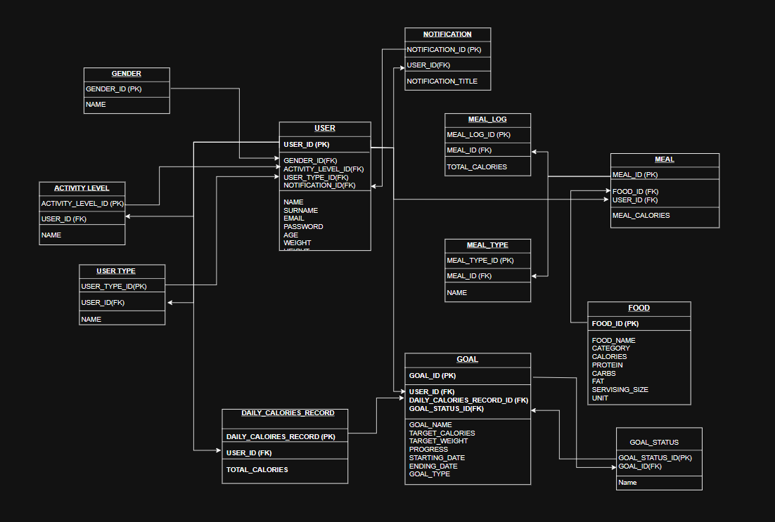

### 

### 

### 

### 

### 

### 

### 

### 

### 

### 

### 

### ***3. Activity Diagram for “Search Food” Operation***

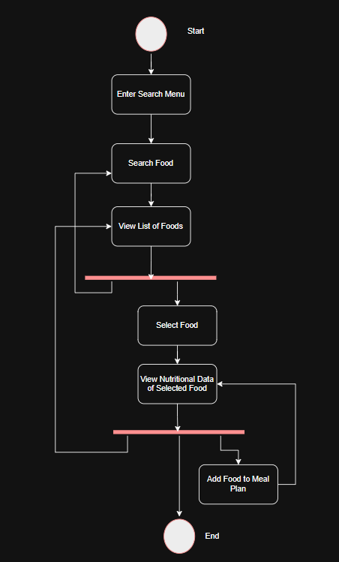

### 

### 

### 

### ***4. Activity Diagram for “Calculate Calorie Allowance” Operation***

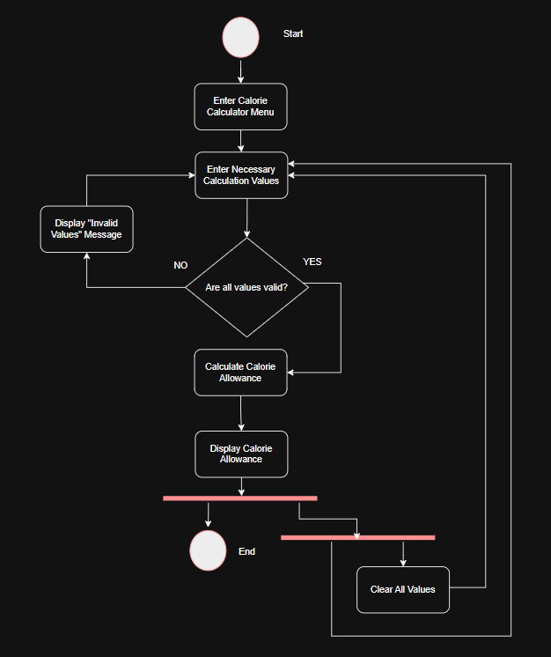

### 

### 

### 

### 

### ***5. Activity Diagram for “Track Goals Progress” Operation***

